Database Setup

1. **Create a database 'Tenant'**
2. **Create tables with the following specifications.**
   1. **Tenancy_histories**

|  |  |  |  |  |
| --- | --- | --- | --- | --- |
| **Field** | **Type** | **Null** | **Key** | **Default** |
| id | Int | NO | PRI | auto_increment |
| profile_id | Int | NO | FK |  |
| house_id | Int | NO | FK |  |
| move_in_date | date | NO |  |  |
| move_out_date | date | YES |  |  |
| rent | Int | NO |  |  |
| Bed_type | varchar(255) | YES |  |  |
| move_out_reason | varchar(255) | YES |  |  |

* 1. **Profiles**

|  |  |  |  |  |
| --- | --- | --- | --- | --- |
| **Field** | **Type** | **Null** | **Key** | **Default** |
| profile_id | int | NO | PRI | auto_increment |
| first_name | varchar(255) | YES |  |  |
| last_name | varchar(255) | YES |  |  |
| email | varchar(255) | NO |  |  |
| phone | varchar(255) | NO |  |  |
| city(hometown) | varchar(255) | YES |  |  |
| pan_card | varchar(255) | YES |  |  |
| created_at | date | NO |  |  |
| gender | varchar(255) | NO |  |  |
| referral_code | varchar(255) | YES |  |  |
| marital_status | varchar(255) | YES |  |  |

* 1. **Houses**

|  |  |  |  |  |
| --- | --- | --- | --- | --- |
| **Field** | **Type** | **Null** | **Key** | **Default** |
| house_id | int | NO | PRI | auto_increment |
| house_type | varchar(255) | YES |  |  |
| bhk_details | varchar(255) | YES |  |  |
| bed_count | int | NO |  |  |
| furnishing_type | varchar(255) | YES |  |  |
| Beds_vacant | int | NO |  |  |

* 1. **Addresses**

|  |  |  |  |  |
| --- | --- | --- | --- | --- |
| **Field** | **Type** | **Null** | **Key** | **Default** |

|  |  |  |  |  |
| --- | --- | --- | --- | --- |
| ad_id | int | NO | PRI | auto_increment |
| name | varchar(255) | YES |  |  |
| description | text | YES |  |  |
| pincode | int | YES |  |  |
| city | varchar(255) | YES |  |  |
| house_id | int | NO | FK |  |

* 1. **Referrals**

|  |  |  |  |  |
| --- | --- | --- | --- | --- |
| **Field** | **Type** | **Null** | **Key** | **Default** |
| ref_id | int | NO | PRI | auto_increment |
| referrer_id(same as profile id) | int | NO | FK |  |
| referrer_bonus_amount | float | YES |  |  |
| referral_valid | tinyint(1) | YES | 0/1 |  |
| valid_from | date | YES |  |  |
| valid_till | date | YES |  |  |

* 1. **Employment_details**

|  |  |  |  |  |
| --- | --- | --- | --- | --- |
| **Field** | **Type** | **Null** | **Key** | **Default** |
| id | int | NO | PRI | auto_increment |
| profile_id | int | NO | FK |  |
| latest_employer | varchar(255) | YES |  |  |
| official_mail_id | varchar(255) | YES |  |  |
| yrs_experience | int | YES |  |  |
| Occupational_category | varchar(255) | YES |  |  |

1. **Database diagram**

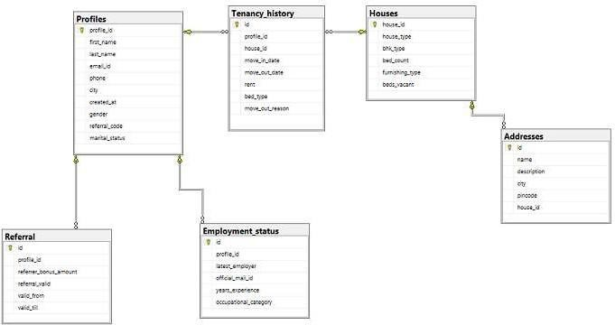

1. **Data to be inserted in given details is provided in form of files**

Project Questions to be answered.

|  |  |
| --- | --- |
| **S.No** | **Question** |
| 1 | Write a query to get Profile ID, Full Name and Contact Number of the tenant who has stayed.  with us for the longest time period in the past |
| 2 | Write a query to get the Full name, email id, phone of tenants who are married and paying.  rent > 9000 using subqueries |
| 3 | Write a query to display profile id, full name, phone, email id, city, house id, move_in_date , move_out date, rent, total number of referrals made, latest employer and the occupational category of all the tenants living in Bangalore or Pune in the time period of jan 2015 to jan  2016 sorted by their rent in descending order |
| 4 | Write a sql snippet to find the full_name, email_id, phone number and referral code of all the tenants who have referred more than once.  Also find the total bonus amount they should receive given that the bonus gets calculated  only for valid referrals. |
| 5 | Write a query to find the rent generated from each city and also the total of all cities. |
| 6 | Create a view 'vw_tenant' find  profile_id,rent,move_in_date,house_type,beds_vacant,description and city of tenants who shifted on/after 30th april 2015 and are living in houses having vacant beds and its address. |
| 7 | Write a code to extend the valid_till date for a month of tenants who have referred more  than one time |
| 8 | Write a query to get Profile ID, Full Name, Contact Number of the tenants along with a new column 'Customer Segment' wherein if the tenant pays rent greater than 10000, tenant falls in Grade A segment, if rent is between 7500 to 10000, tenant falls in Grade B else in Grade C |
| 9 | Write a query to get Fullname, Contact, City and House Details of the tenants who have not  referred even once |
| 10 | Write a query to get the house details of the house having highest occupancy |